Normal Distributions and Stock Price

# Stock price function implementation

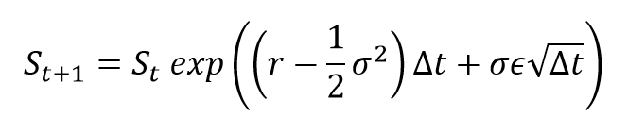

Figure – Stock price function

*Where,*

* *St is the stock price at t (10 USD)*
* *St+1 is the stock price at t+1*
* *r is the expected annual stock return, (Say 0.15)*
* *σ is the annualized volatility of the underlying stock. (0.2)*
* *T is time in Years (1 year)*
* *n is the number of steps involved in calculation, (12 steps)*
* *Δt is the size of the unit step size =T/n ε is the distribution term with a zero mean, (a random value from a normal sample) ε=0.15*

# Stock prices calculation for constant *ε = 0.15*

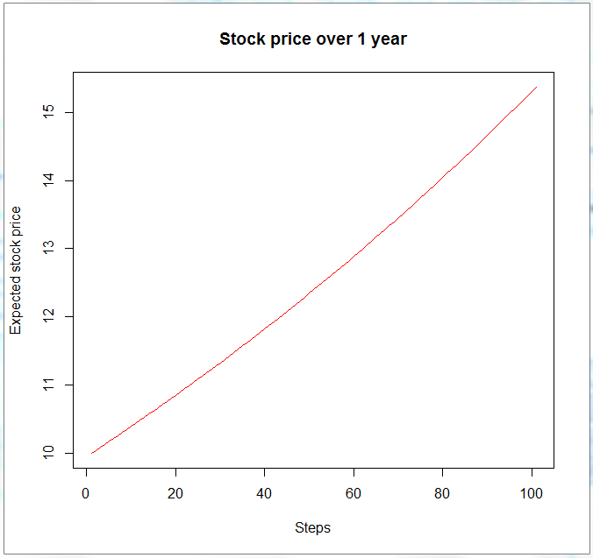

Figure – Stock price movement with constant ε = 0.15

**Conclusion:** in case ε is a constant stock price movement is predictable and has almost no volatility. As we know this result is in contradiction with the real market.

# Stock prices calculation in case *ε* is a random variable from the standard normal distribution.

At first, matrix with 100 rows and 5 columns has been generated from standard normal distribution. After that 5 trials with random *ε* were made. The result of the 5 trials is represented below:

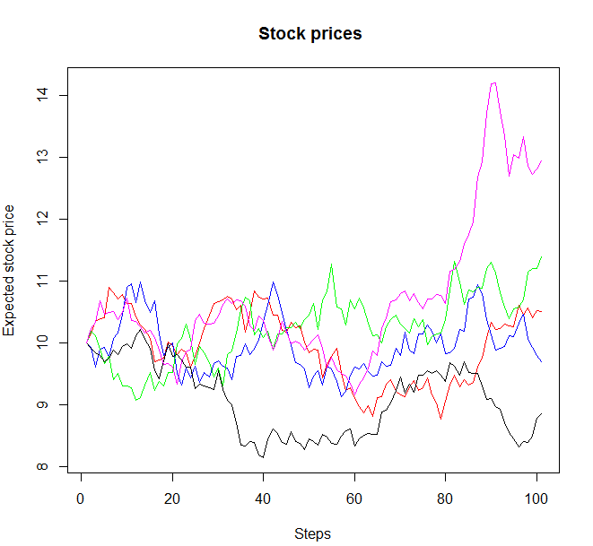

Figure – Stock prices with random ε ( 5 trials, standard normal)

**Conclusion:** it is obvious that there is significant difference in the final result. Based on this results, it is clear that the price cannot be forecasted precisely. Only some assumptions about the price interval are possible. However, this result looks much more similar to the real market price picture.

# Uniform VS Normal

Let us compare two outcomes: one based on *ε* from normal standard distribution and the second one based on *ε* from uniform distribution with borders [-2;2]. Based on empirical rule, 95% of data are between [mean – 2*st.dev. ; mean + 2* st.dev], so that is why -2 and 2 have been chosen. The simulation result is represented below:

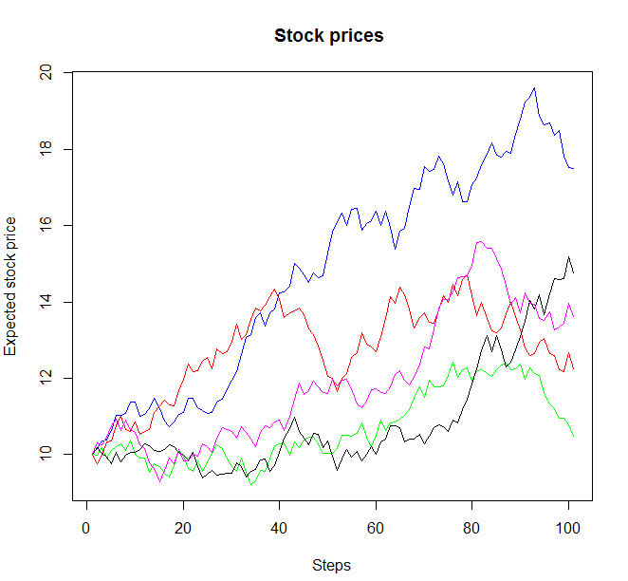

Figure - Stock prices based on uniform distribution

**Conclusion:** comparing with normally distributed *ε, ε* that are from uniform distribution, provide prices with higher variance or lower variance.So, it is not possible to say that normal distribution provides always lower price variance. However, after 5000 simulations it became clear that prices variance based on normal distribution in average in 1.72 times lower than prices variance based on uniform one. Actually, it is expected since normal distribution has bell-shaped probability, uniform probability is equally distributed.